DIAGNOSING HOSPITAL BOTTLENECKS: A PATIENT FLOW & WAIT-TIME ANALYTICS DASHBOARD

ABSTRACT
The Diagnosing Hospital Bottlenecks: A Patient Flow & Wait-Time Analytics Dashboard project analyses hospital patient-visit data to understand patient flow, waiting-time patterns, department performance, treatment duration, and patient satisfaction. The dataset contains 1,000 patient-visit records with information such as department, gender, age, visit type, doctor, insurance type, patient status, waiting time, treatment duration, length of stay, and satisfaction score. The data is prepared and analysed using Excel and SQL, while Power BI is used to create an interactive dashboard with KPI cards, charts, slicers, conditional formatting, and drill-through analysis. The dashboard helps identify differences in department performance, patient flow patterns, waiting times, and doctor workload. The project provides useful insights that can support hospital operational monitoring and data-driven decision-making.

INTRODUCTION
Healthcare organizations handle a large number of patient visits every day. Monitoring patient flow, waiting time, treatment duration, department workload, and patient satisfaction is important for improving operational efficiency. This project analyzes 1,000 patient-visit records to identify operational patterns and potential hospital bottlenecks.

PROBLEM STATEMENT
Hospitals generate patient data across different departments and visit types, but raw data alone does not clearly show where delays or operational issues occur. A centralized analytical dashboard is required to monitor patient volume, waiting time, treatment efficiency, department performance, and patient satisfaction.

OBJECTIVES
- Analyze overall patient volume and patient flow.
- Identify departments with higher waiting times.
- Compare department performance.
- Analyze waiting time by visit type and patient status.
- Evaluate doctor workload based on number of visits.
- Analyze treatment duration and length of stay.
- Study patient satisfaction.
- Build an interactive Power BI dashboard for operational monitoring.

DATASET DESCRIPTION
The project uses a dataset containing 1,000 patient-visit records with information such as patient ID, visit date, department, gender, age, visit type, doctor ID, insurance type, patient status, waiting time, treatment duration, length of stay, and satisfaction score.

TOOLS & TECHNOLOGIES
- Excel – Data cleaning and preparation
- SQL/MySQL – Data querying and analysis
- Power BI – Dashboard development and visualization
- DAX – KPI and calculated measures
PROJECT WORKFLOW
Raw Healthcare Dataset → Excel Data Cleaning & Preparation → MySQL → SQL Analysis → Power BI → Dashboard → Insights & Recommendations

DATA CLEANING & PREPARATION
The dataset was checked for missing values, duplicate records, incorrect data types, and inconsistent text values. Missing insurance values were handled using an Unknown category, while missing waiting-time values were handled using the median waiting time. Duplicate records were checked and removed where applicable.
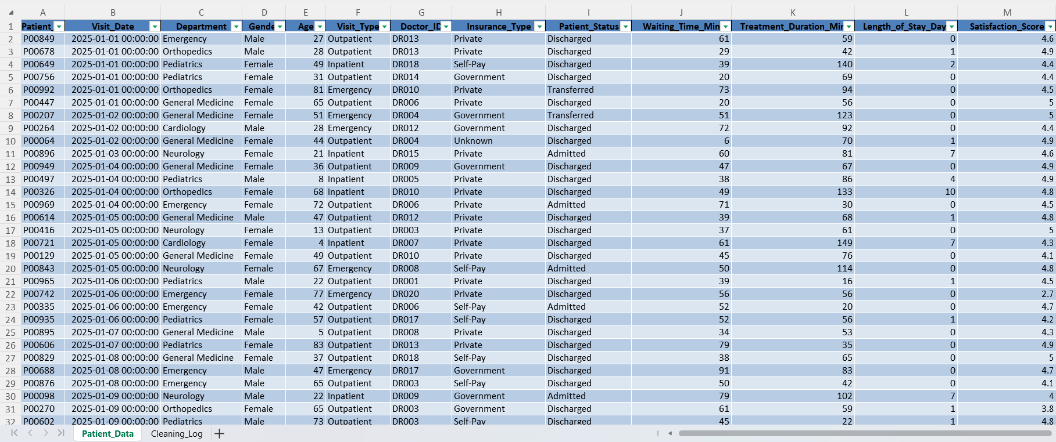
Figure 1: Data Cleaning and Preparation using Excel

SQL ANALYSIS
SQL was used to analyze:
- Average waiting time
- Department performance
- Visit-type performance
- Patient-status analysis
- Doctor workload
- Department master data using JOIN
- Department summaries using CTE
- Department waiting-time ranking using RANK()
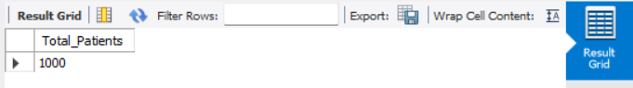
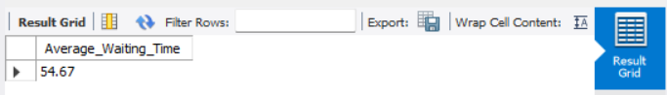
Figure 2: Overall Patient Volume and Average Waiting Time Analysis using MySQL

KEY PERFORMANCE INDICATORS
The Power BI dashboard includes:
- Total Visits: 1,000
- Average Waiting Time: 54.67 minutes
- Average Treatment Duration: 71.18 minutes
- Average Satisfaction: 4.41 / 5

DEPARTMENT PERFORMANCE ANALYSIS
Department-level analysis was performed to compare total patient visits, average waiting time, treatment duration, and satisfaction. This helps identify departments that experience relatively higher waiting times and may require further operational investigation.
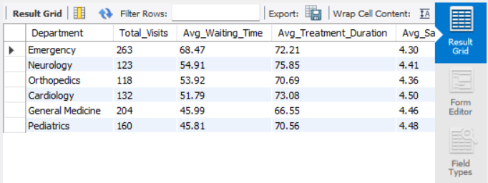
Figure 3: Department Performance Analysis using MySQL

PATIENT FLOW & VISIT PATTERN ANALYSIS
Patient visits were analyzed across departments, visit types, patient statuses, and months. These patterns help understand how patient demand varies and support better operational planning.
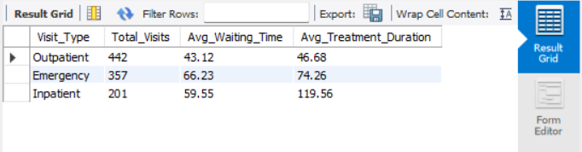
Figure 4: Visit Type Analysis using MySQL
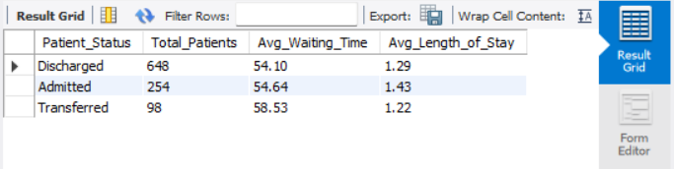
Figure 5: Patient Status Analysis using MySQL

DOCTOR WORKLOAD ANALYSIS
Doctor workload was evaluated using the number of patient visits handled by each doctor. Waiting time and treatment duration were also compared to understand workload and service-efficiency patterns.
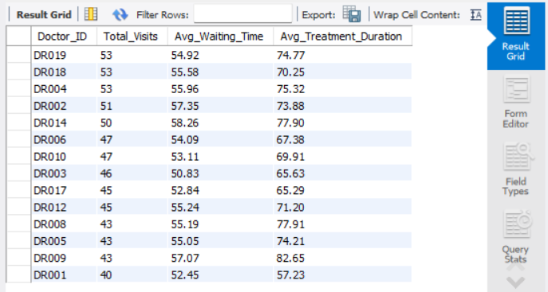
Figure 6: Doctor Workload Analysis using MySQL

POWER BI DASHBOARD
An interactive four-page dashboard was developed:
Page 1 - Patient Flow & Wait-Time Overview
Provides overall KPIs, department comparison, patient volume, and monthly patient trends.
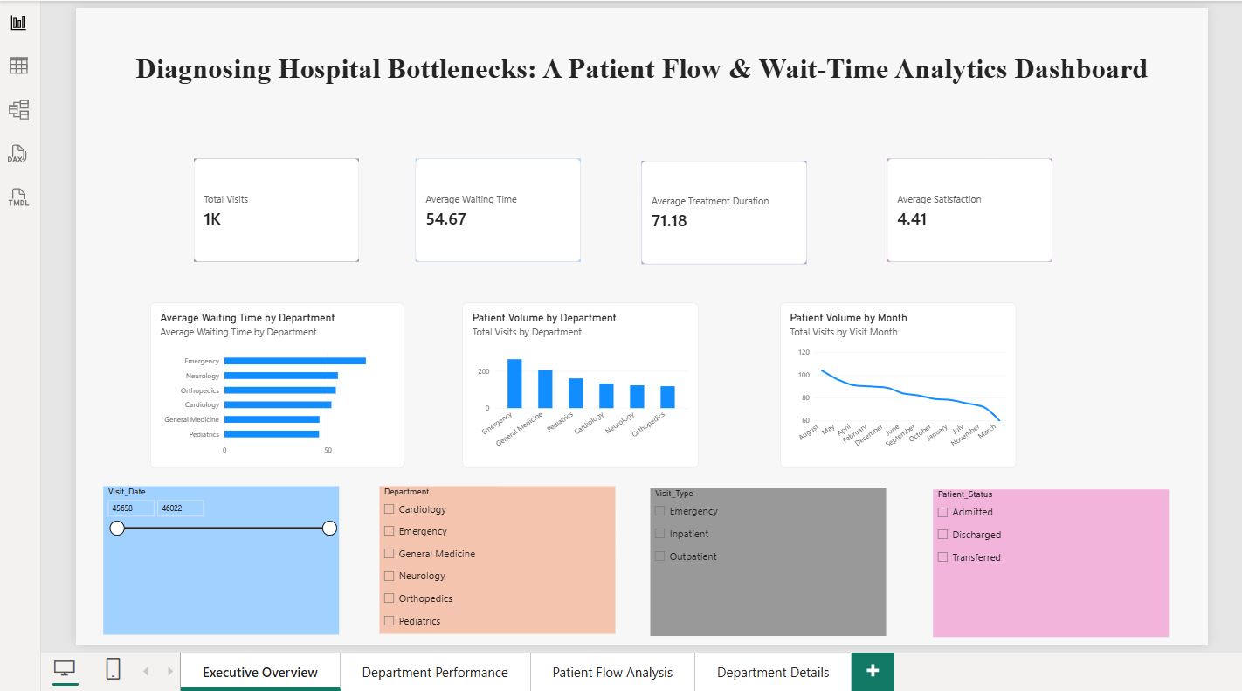
Page 2 - Department Performance & Waiting Time Analysis
Compares department waiting time, patient volume, treatment duration, and workload patterns.
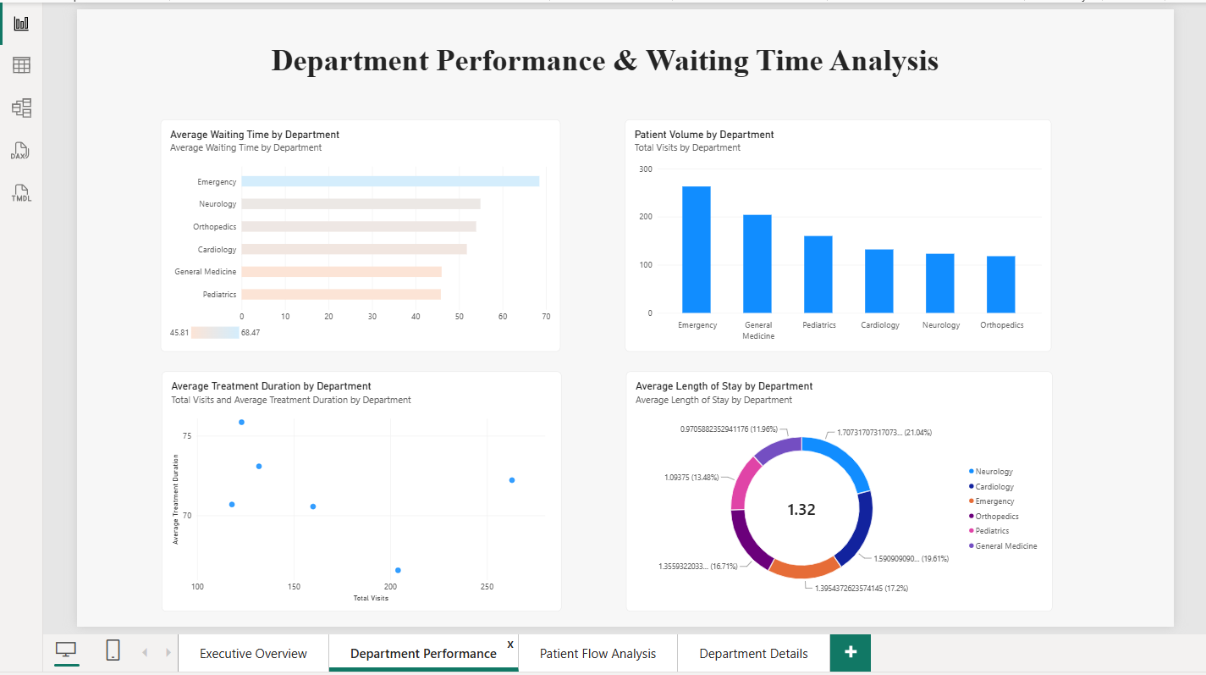

Page 3 - Patient Flow & Visit Pattern Analysis
Analyzes waiting-time trends, visit types, and patient-status distribution.
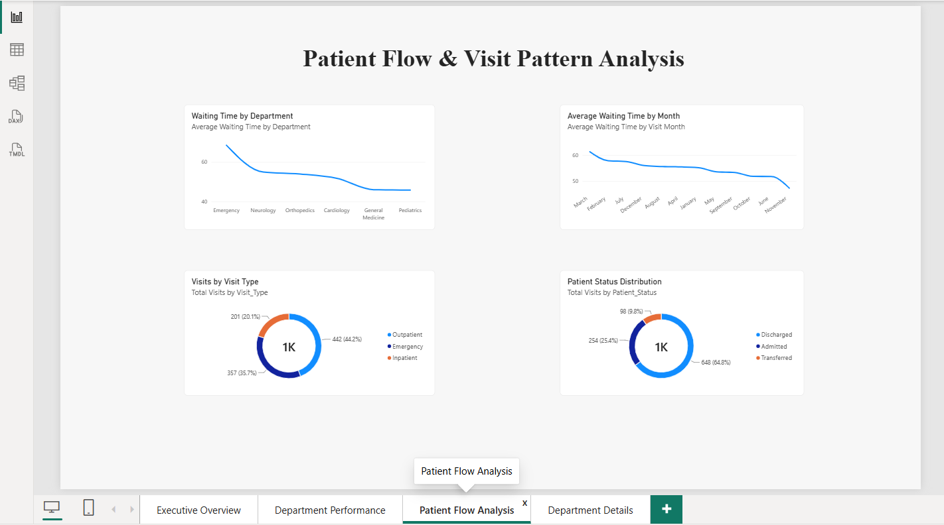
Page 4 - Department Details & Patient Records
Provides department-level drill-through analysis and detailed patient records.
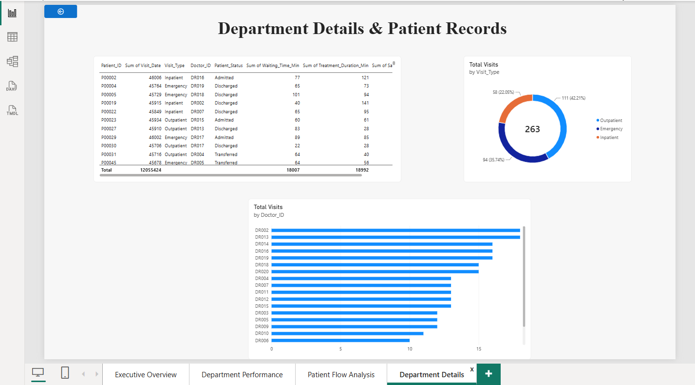

DASHBOARD FEATURES
- KPI Cards
- Slicers
- Bar/Column Charts
- Donut Charts
- Scatter Chart
- Conditional Formatting
- Drill-through Analysis
- DAX Measures

KEY FINDINGS
The analysis provides a centralized view of hospital operations and makes it easier to identify departments with higher waiting times, understand patient-volume patterns, compare doctor workloads, and evaluate treatment efficiency and patient satisfaction.

BUSINESS RECOMMENDATIONS
- Reduce Waiting Time: Identify departments with higher waiting times and review patient-flow processes to minimize delays.
- Optimize Doctor Workload: Monitor patient distribution across doctors to support effective workload allocation and improve service efficiency.
- Improve Department Efficiency: Evaluate departments with high patient volumes or longer treatment durations and allocate resources based on operational needs.
- Enhance Patient Satisfaction: Monitor satisfaction alongside waiting time and treatment duration to improve the overall patient experience.
- Enable Data-Driven Monitoring: Use the Power BI dashboard to regularly track operational KPIs and identify potential bottlenecks for timely action.

CONCLUSION
The project successfully demonstrates how healthcare data can be analyzed to understand patient flow, waiting times, treatment efficiency, department performance, and patient satisfaction. The combination of Excel, SQL, and Power BI provides a structured approach to transform raw patient data into meaningful operational insights. The interactive dashboard enables healthcare teams to monitor key performance indicators and identify areas that may require improvement. Overall, the analysis supports data-driven decision-making and better hospital operational management.

REFERENCES
- Microsoft Power BI Documentation
- MySQL Documentation
- Microsoft Excel Documentation
- Microsoft DAX Documentation

